Ex.no:7 | DATA VISUALIZATION USING TABLEAU

Aim:
To connect, analyze, and visualize the diabetic healthcare dataset using Tableau and create interactive worksheets, filters, parameters, dashboards, and stories to analyze patient demographics and hospital stay patterns.
Algorithm:
- Connect Dataset: Connect diabetic_data.csv to Tableau and verify the imported healthcare data.
- Create Worksheets: Create worksheets using relevant fields from the dataset such as Gender, Race, Age, and Time In Hospital.
- Create Visualizations:
  - Create a bar chart to analyze average hospital stay by gender.
  - Create a pie chart to analyze patient distribution by race.
  - Create a visualization to analyze hospital stay across age groups.
  - Create a chart to compare average hospital stay.
- Create Calculated Field: Create a calculated field using Time In Hospital for analysis and filtering.
- Apply Filter: Apply a filter based on Gender to interactively analyze selected patient groups.
- Create Parameter: Create a Minimum Hospital Stay parameter and display patients/records satisfying the selected minimum stay condition.
- Create Dashboard: Combine the created worksheets into an interactive Hospital Data Analysis Dashboard and arrange the visualizations appropriately.
- Create Story: Create a Tableau story using the dashboard and worksheets to present the patient demographic and hospital stay analysis.
- Analyze Results: Observe the visualizations, filters, and parameter changes to identify patterns in the diabetic healthcare dataset.
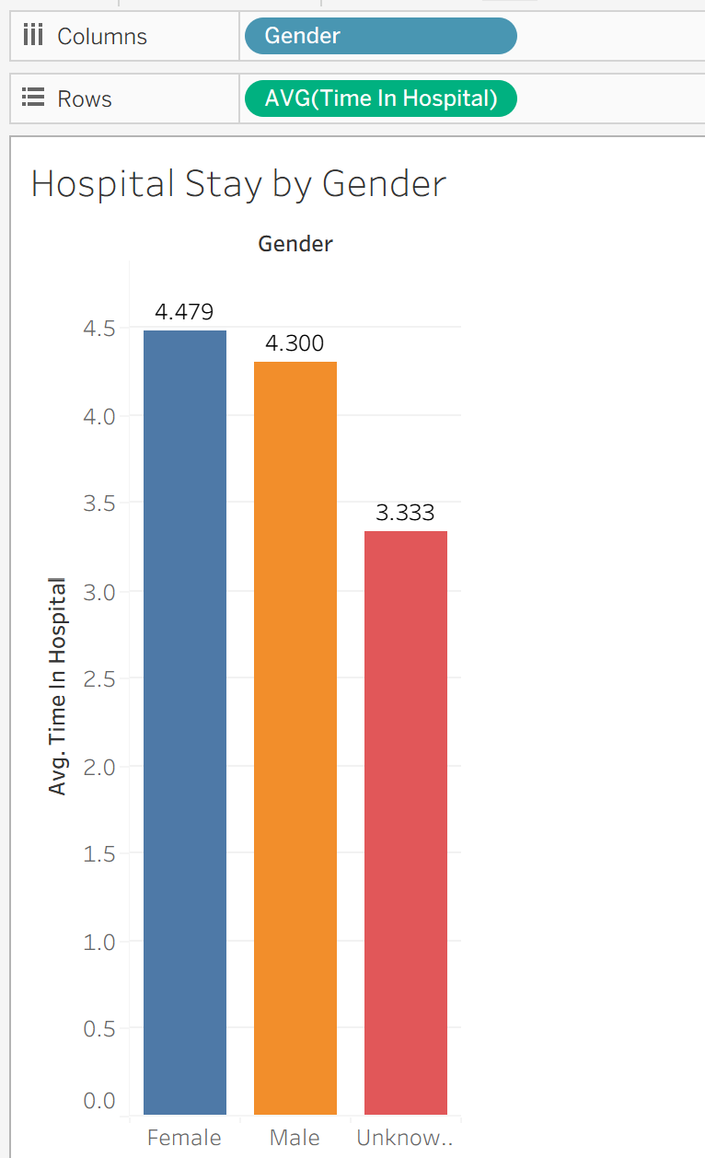
Output:

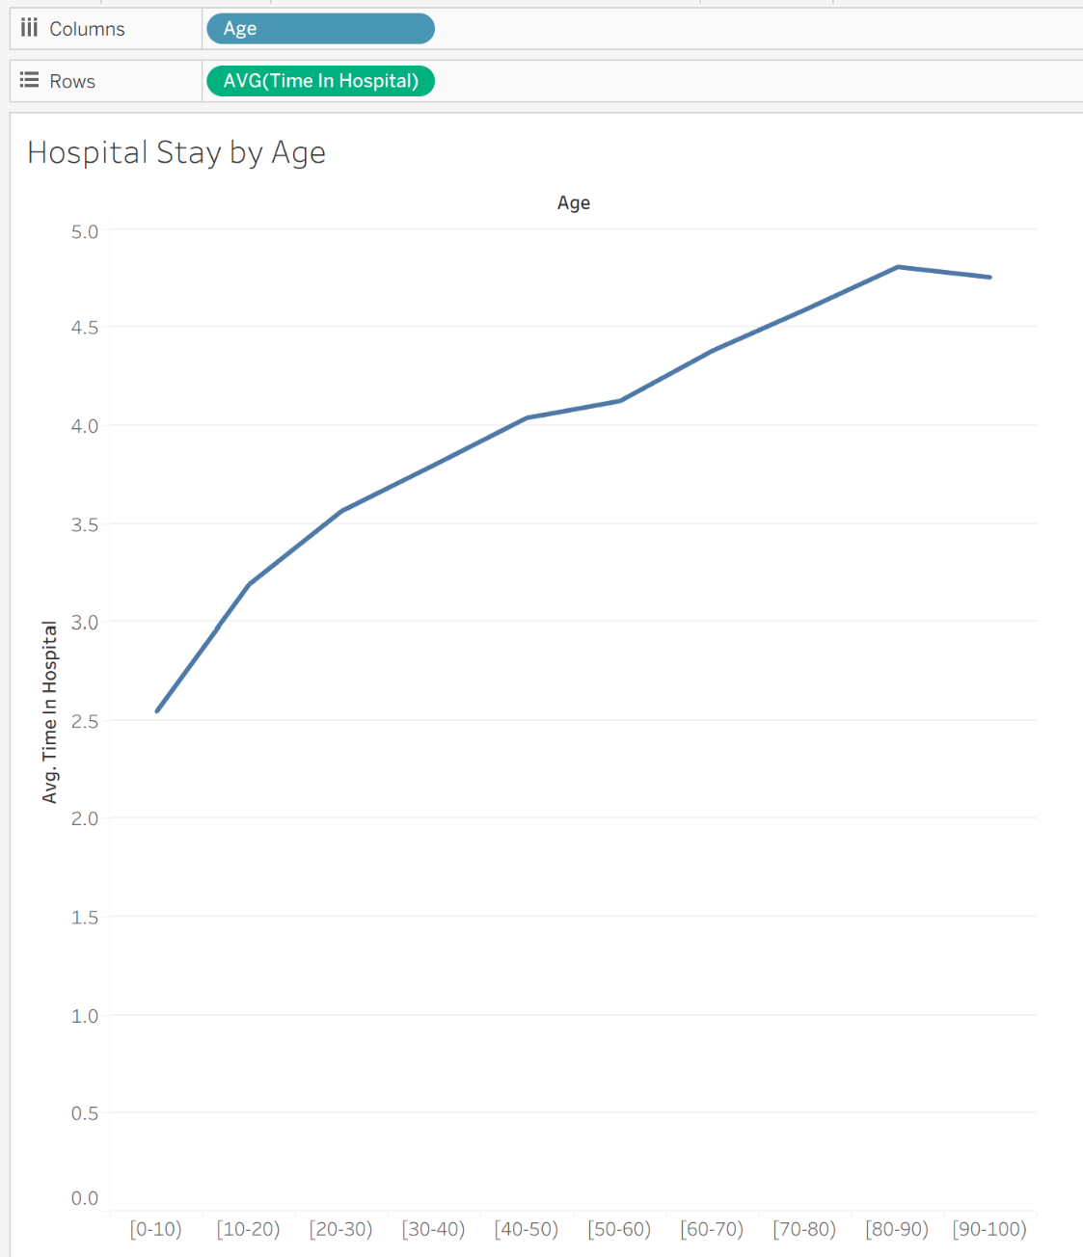
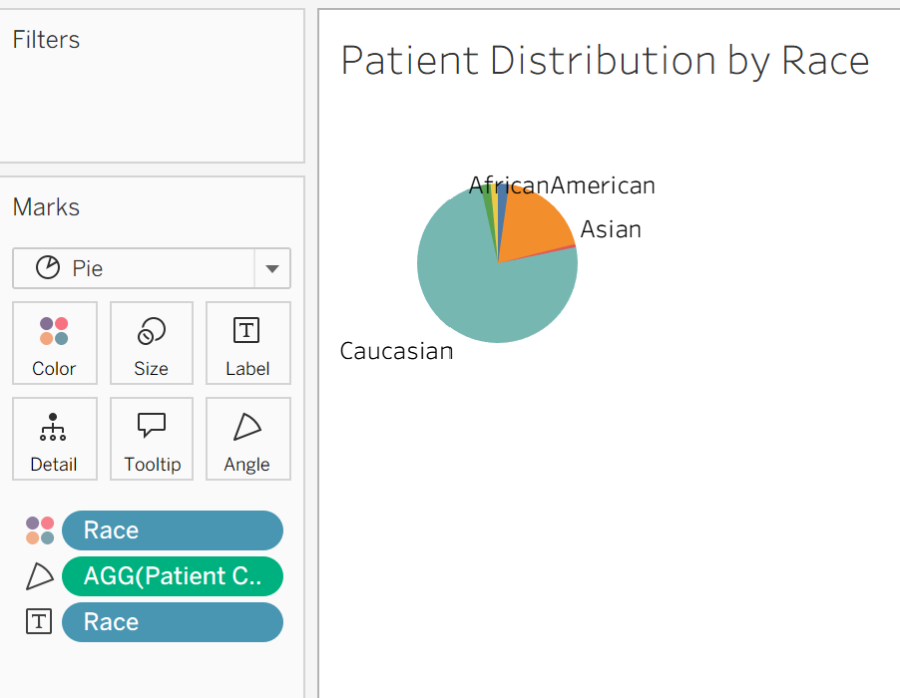

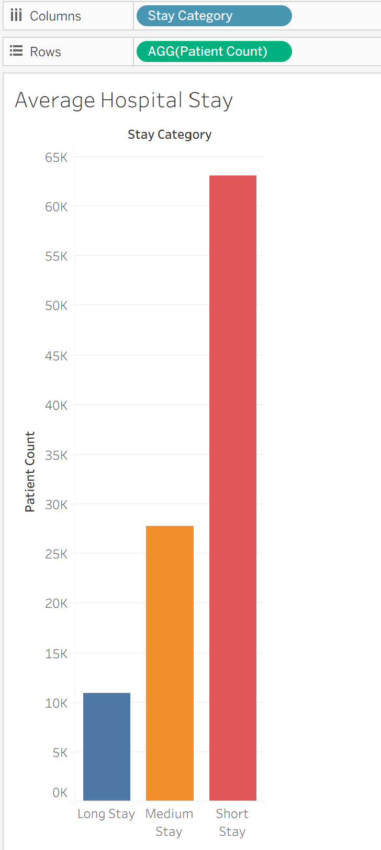

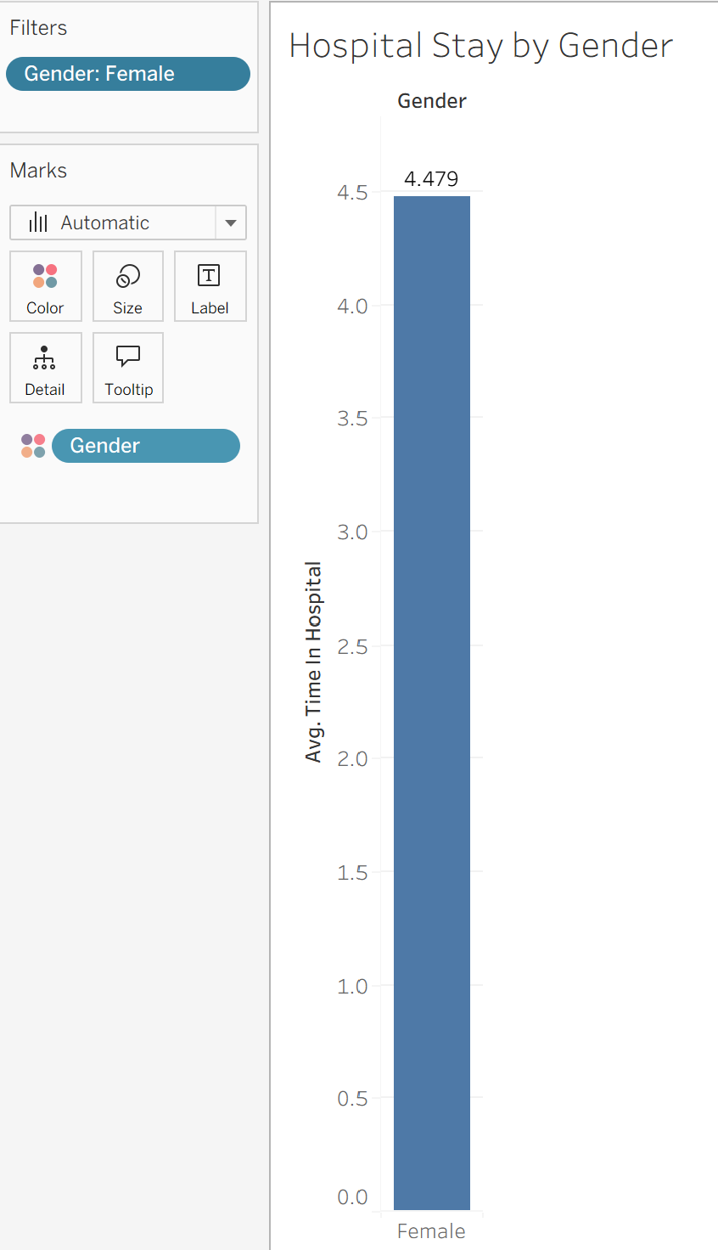

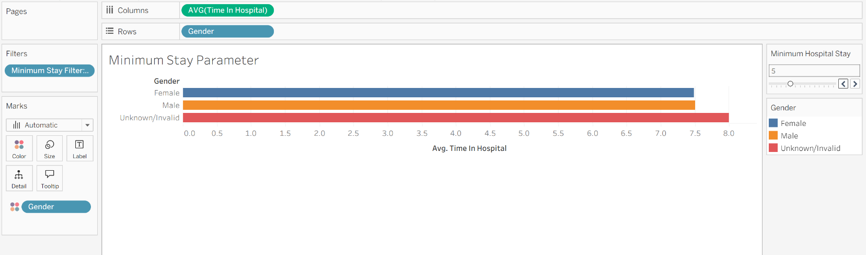
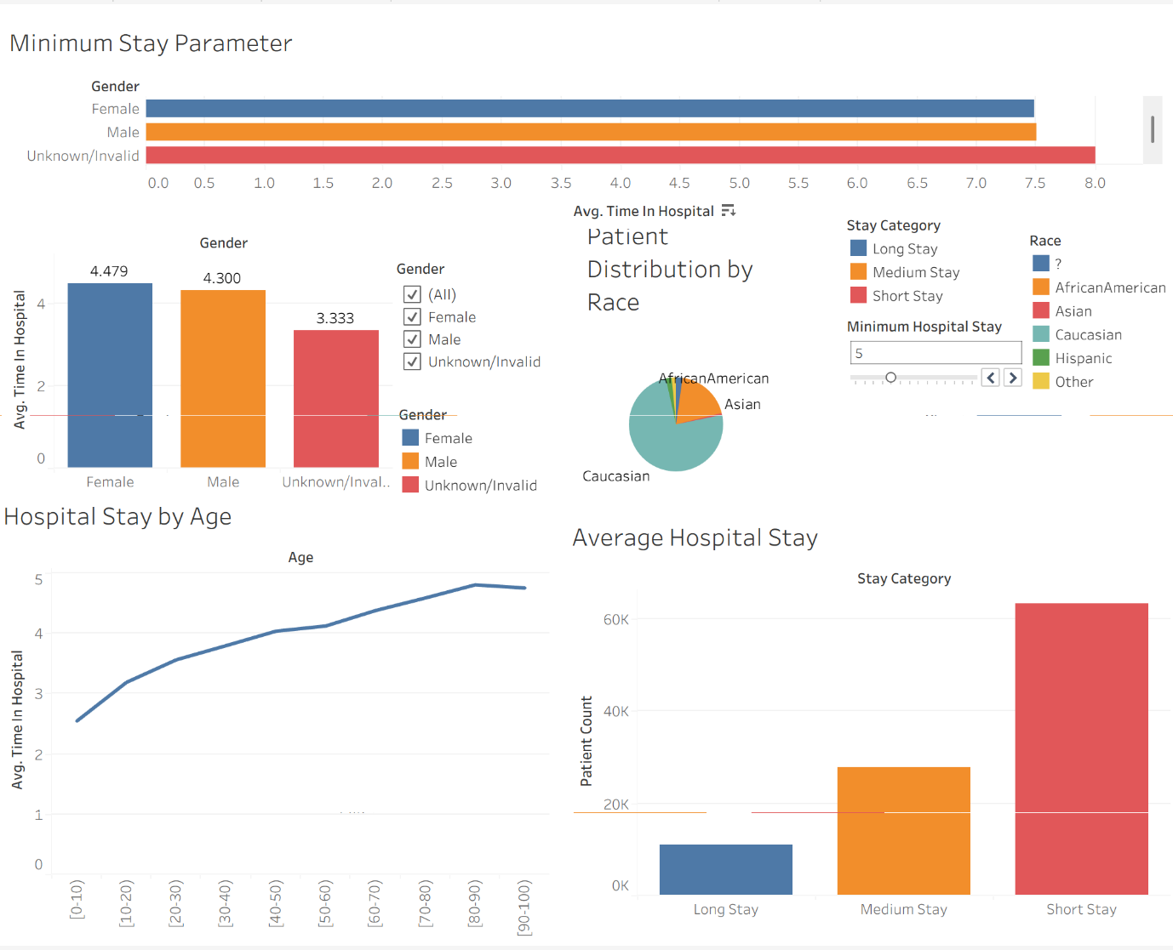

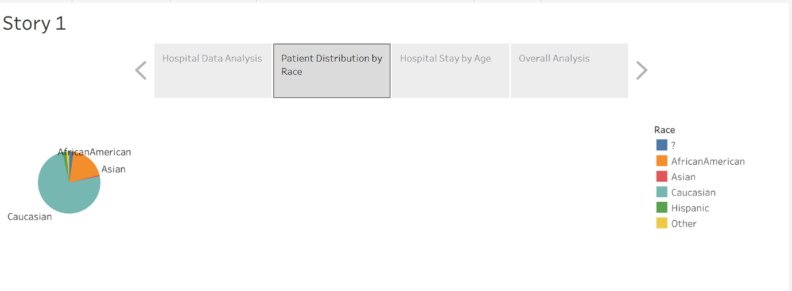

Result:

